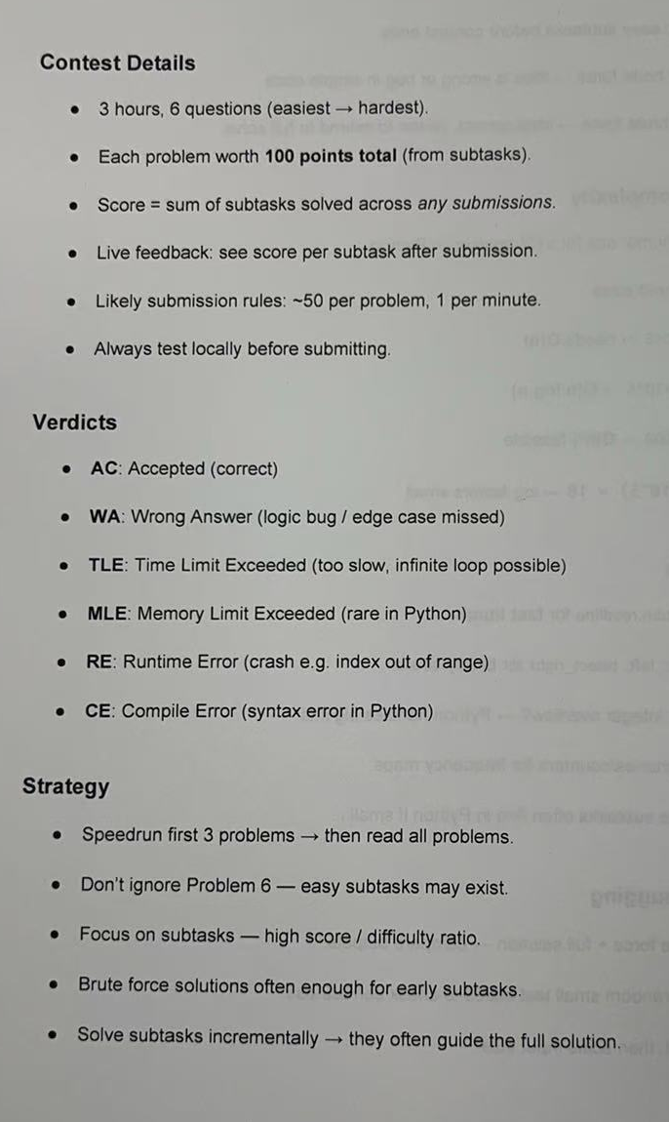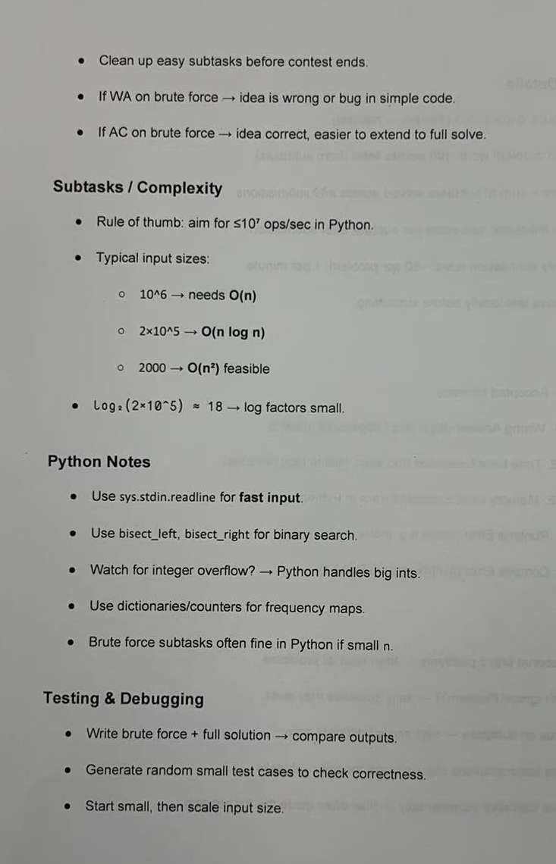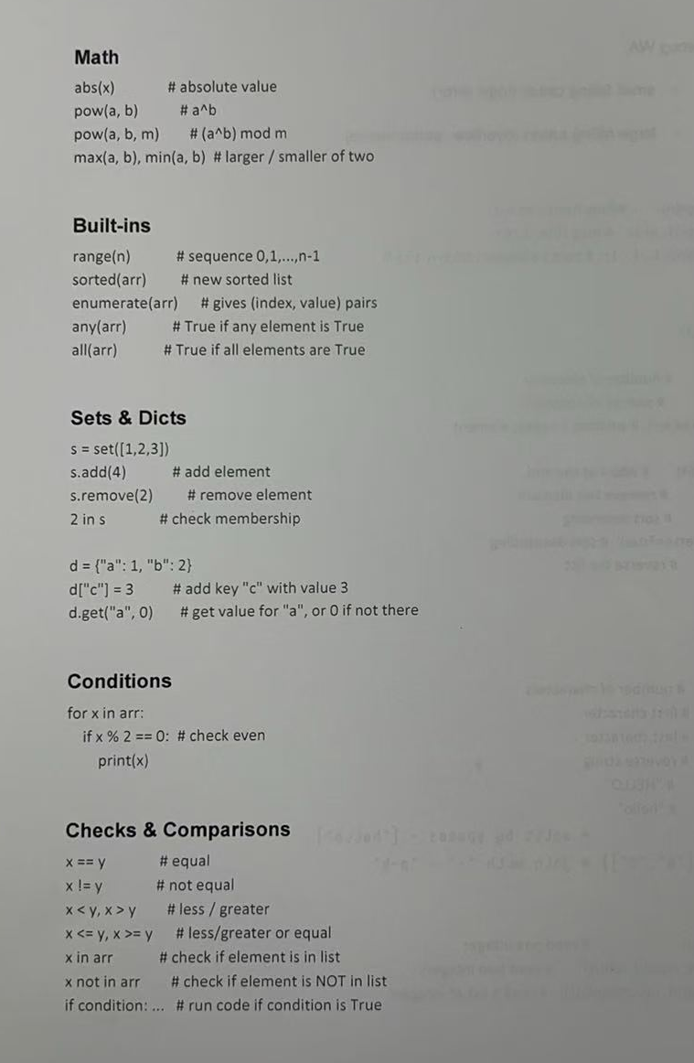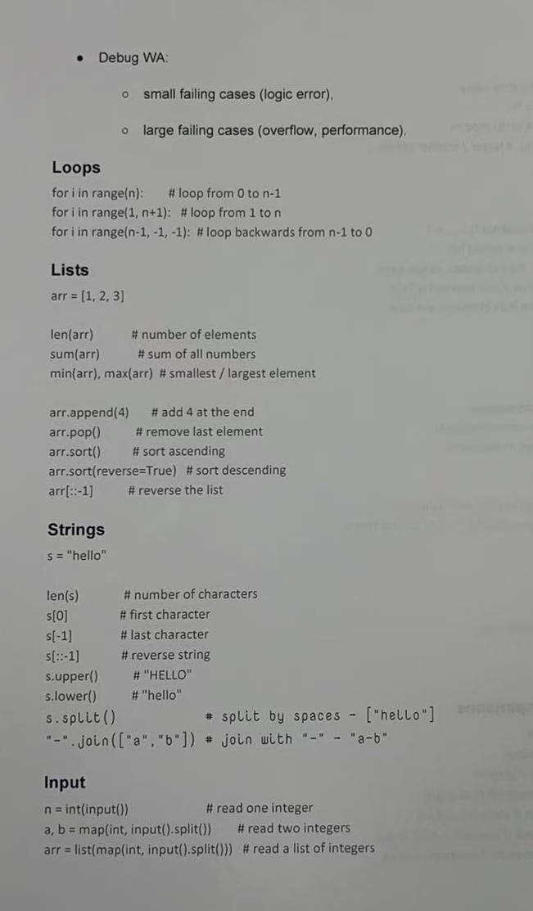
Greedy Algorithms

Greedy algorithms are a common type of algorithm seen in informatics solutions. Let's jump right in with an example: Fashion Statement from AIO 2006. In this problem, you need to carry exactly t dollars using the fewest notes possible. There are 4 denominations of notes available to you: 1, 5, 20, and 100 dollars. You have an unlimited supply of each.
Spend some time thinking about how to solve this problem. Then, click to reveal my solution idea.
Intuitively, it is better to use bigger notes rather than smaller notes. This inspires a solution: We choose one note at a time, always choosing the biggest possible note.
For example, if we need t = 167 dollars, then we would do the following:
- Choose a 100-dollar note. We now need 67 more dollars.
- Choose a 20-dollar note. We now need 47 more dollars.
- Choose a 20-dollar note. We now need 27 more dollars.
- Choose a 20-dollar note. We now need 7 more dollars.
- Choose a 5-dollar note. We now need 2 more dollars.
- Choose a 1-dollar note. We now need 1 more dollar.
- Choose a 1-dollar note. We now have 167 dollars, and are finished.
This uses 7 notes.
This algorithm has a time complexity of , which is fast enough to score all 100 points on this problem. In code, this might look like:

answer = 0
while t > 0:
if t >= 100:
t -= 100
answer += 1
elif t >= 20:
t -= 20
answer += 1
elif t >= 5:
t -= 5
answer += 1
else:
t -= 1
answer += 1
My solution is called a greedy algorithm because it tries to make the best choice at each step, without thinking about future choices. But how do we know whether this algorithm always uses the fewest number of notes? To convince ourselves, we either need a proof that it works, or a proof that it doesn't work:
- To prove that a solution works, we need an argument as to why it works on every possible case.
- To prove that a solution doesn't work, we just need one test case where it fails. This is often called a breaking case.
Try to prove or disprove my solution, and then click to reveal my reasoning.
The solution is correct! To prove this, we need to understand why it is always better to take a higher valued note over a lower valued note:
- If we had five 20-dollar notes, it is always better to replace these with a single 100-dollar note, since both options have the same value but the second option uses fewer notes.
- If we had four 5-dollar notes, it is always better to replace these with a single 20-dollar note, using the exact same reasoning as above.
- If we had five 1-dollar notes, it is always better to replace these with a single 5-dollar note, using the exact same reasoning as above.
Therefore, it is always best to take the biggest note possible, and so the solution is correct.
Another Example
Our next example is the same problem as before, except you now have the following notes available to you: 1, 6, 20, and 100 dollars. Notably, the 5 dollar note has been replaced by a 6 dollar note. Does our previous solution work? Have a think about it, and then click to see whether you are correct.
No! Many problems cannot be solved using a greedy algorithm, and this is one of them. Our old proof does not work because you cannot make 20 using just 6-dollar notes. Therefore, there might be situations where it is better to choose a 6-dollar note rather than a 20-dollar note.
To prove that the greedy solution is incorrect, we can make a test case where the greedy solution uses too many notes. Can you find one?
A common mistake for newer students is using greedy algorithms when they don't work, causing them to score 0 points. To avoid this happening to you, always be careful when using a greedy algorithm!

Prefix Sums

One common component of algorithm design is precomputation. That is, taking part of an algorithm that would normally be slow and making it faster by doing some upfront work. That's a little abstract, so let's dive straight in with an example problem.
Mansion (AIO 2007)
Have a read of the problem Mansion from AIO 2007 and spend a few minutes trying the problem for yourself. In summary, you're given an array (for python users: an array is another word for a list) of integers and must find a contiguous section of the array (often called a subarray, or an interval) that contains exactly elements and has the largest sum.
One straightforward approach is to note that there are only possible intervals (watch out for off-by-one errors!), so we could try summing up each interval and taking the best one. The code looks something like this:
N, K = map(int, input().strip().split())
people = []
for i in range(N):
people.append(int(input().strip()))
# Tracks the interval with the largest sum
# we've seen so far.
most_people = -1
for start in range(N - K + 1):
# Find the sum of the interval from [start..start+K-1]
current_people = 0
for i in range(K):
current_people += people[start+i]
# If the current interval has a larger sum
# than the most we've seen, then update.
if current_people > most_people:
most_people = current_people
print(most_people)
The worst-case time complexity of this approach is (check for yourself that this is true) and would only score 50 out of 100 points for this problem. The part that's slow is the inner for-loop that calculates the sum of each interval as we need it. Is there a better way?
Prefix sums
We can start our algorithm by precalculating a prefix sum table (a.k.a cumulative sums, partial sums) that lets us calculate the sum of each interval much faster. Consider this example:

The blue (top) interval can be calculated by taking the red (bottom) interval and subtracting the green (middle) interval. Notice that the green and red intervals are both prefixes -- that is, they start from the beginning of the array. What's useful here, is that the sum of any interval of the array can be calculated as the difference between two prefixes.

This means that if we precalculate the sum of every prefix of an array, we can then calculate the sum of any interval (not just prefixes) in time! Calculating the prefix sums takes time if done efficiently. This allows us to get 100 points on Mansion.
In summary, prefix sums are a data structure that can be created in time and let you query the sum of any interval in time. It's a very powerful building block for more complex algorithms!

Two Pointers

Mansion (AIO 2007)
In the Prefix Sum tutorial, we presented a solution for Mansion that used precomputation to solve the problem in time. Here, we will present a different solution that also runs in time.
This solution has roughly the same structure: we will consider each interval one at a time, and store the maximum interval sum that we find. We begin by summing up the first interval (that goes from index 0 to index ), and this takes time. Then, we want to find the sum of the second interval (that goes from index 1 to index ). Notice that these intervals are very similar: the only differences occur at index 0 and index . In particular, we want to subtract the value at index 0, because this is no longer included in the range, and add the value at index . Doing this gives us the sum of the second interval, but only takes time!
This technique is often called sliding window or two pointers.
The video below shows this solution being applied to the sample input.
Overall, this solution has a time complexity of , which is the same time complexity as the prefix sum solution. Both solutions are equally good and will earn all 100 points!
Wet Chairs (AIO 2015)
Let's look at Wet Chairs from AIO 2015. Spend a few minutes trying the problem for yourself before reading my solution.
Solution 1
We are trying to minimise the distance between our leftmost and rightmost friend. When seating our friends, only three things matter:
- The location of the leftmost friend.
- The location of the rightmost friend.
- There must be enough chairs between the leftmost and rightmost friend to fit everyone. Notably, there must be at least chairs, and at least of them must be dry.
Where should the leftmost friend be seated? This is a hard question to answer, and so instead we will try every option and take the best! One at a time, trying every option for the leftmost chair, we count the total number of chairs and dry chairs until we have enough to fit everyone. We then output the smallest distance between leftmost and rightmost chair that we saw across all of the options.
read input
# The variable least_chairs_needed will eventually store the answer
# The maximum possible answer is C, because the problem guarantees us it will always be possible to seat everyone
least_chairs_needed = C
# Try each leftmost chair individually
for leftmost_chair = 1 to C:
num_chairs = 0
num_dry_chairs = 0
# loop over the chairs, starting with our chosen leftmost chair
for i = leftmost_chair to C:
num_chairs += 1
if chair i is dry:
num_dry_chairs += 1
if num_chairs >= N and num_dry_chairs >= N-K:
# We can seat everyone!
if num_chairs < least_chairs_needed:
# Update our answer each time we find a better solution
least_chairs_needed = num_chairs
# this will exit out of the inner-most loop but not the outer loop,
# so that we can try the next option for the leftmost chair
break
output least_chairs_needed
This solution has a worst-case time complexity of , because in the worst case it will spend time considering each leftmost chair, and there are options for the leftmost chair. This will earn 40 marks (subtask 1 and subtask 2).
Solution 2
Our goal is to solve wet chairs in time. Before we do this, let's think carefully about our previous solution.
Notice that as we go through possibilities for the leftmost chair, the corresponding closest rightmost chair can only move rightwards (or stay still). For example if we try chair number 3 as the leftmost chair and find that the closest rightmost chair that can seat everyone is chair 7, then for leftmost chair number 4, the closest rightmost chair that can seat everyone must be chair 7 or larger, it couldn't possibly be chair 6 or earlier (think about why this is the case).
Now, can you use this to solve the problem in a way that is similar (but not necessarily exactly the same) as the way we solved Mansion? Spend some time thinking about this, and only look at my solution if you get stuck!
Our approach will be very similar to the previous solution: We will try every possible leftmost chair, and find the earliest possible rightmost chair that allows us to fit everyone. Previously, we calculated the rightmost chair independently for each leftmost chair in time. We will use the two pointers technique to improve this.
Before I explain my solution, watch the below video that shows it being applied to an example input with , , and ().
We first assume that the leftmost chair is chair 1, and run the same procedure as before that counts the total number of chairs and the total number of dry chairs, stopping once there are enough chairs for everyone. We then assume that the leftmost chair is chair 2. To improve the time complexity, we don't start again from stratch. Instead, we start from the previous rightmost chair:
- We subtract one from the num_chairs variable, because chair 1 is no longer included.
- If chair 1 was dry, we subtract 1 from the num_dry_chairs variable.
If we have enough chairs to seat everyone, then we stop and move to chair 3. Otherwise, we continue to increase the position of the rightmost chair until there are enough chairs to seat everyone. We do this for all choices of leftmost chair.
What is the time complexity of this solution? It might not seem like it, but it's . Specifically, notice that our leftmost and rightmost chairs only ever move towards the right. This means that we only consider intervals at most. We do work for each interval, so the overall time complexity time complexity is . This is fast enough to score 100 for this problem.

Soccer Match | Simulation / prefix running total | Scan the goal sequence once and check whether your team's running score ever overtakes the opponent's.

N = 0

G = []
N = int(input().strip())
G = list(map(int, input().strip().split()))
t1, t2 = 0,0
l = False

for i in G:
if i == 1:
t1 += 1
else:
t2 += 1

if t1 > t2:
l = True

if l == True:
print("YES")
else:
print("NO")

Buried Treasure | Interval intersection (math/greedy) | Intersect N clue-ranges by taking the max of all left ends and min of all right ends to count valid locations.

N = 0
L = 0

A = []
B = []

N, L = map(int, input().strip().split())
for i in range(0, N):
input_vars = list(map(int, input().strip().split()))
A.append(input_vars[0])
B.append(input_vars[1])

left, right = 0, L
answer = 0
for h in A:
if h > left:
left = h
for h in B:
if h < right:
right = h

answer = max(0,right-left+1)

print(answer)

Off the Track | Greedy + binary search on the answer | Choose a sequence of "forwards"/"backwards" calls that clears students off both ends of a track in as few seconds as possible.

N = 0
L = 0

P = []

N, L = map(int, input().strip().split())
P = list(map(int, input().strip().split()))

answer = min(L-P[0], P[N-1])
for i in range(0,N-1):
answer = min(answer, P[i]+2*(L-P[i+1]))
answer = min(answer, 2*P[i]+L-P[i+1])

print(answer)

Javelin | Simulation / running maximum | Count how many throws set a new "furthest so far" record as you scan the results in order.

N = 0
D = []

N = int(input().strip())
D = list(map(int, input().strip().split()))

answer = 0
current_leader = 0
for _ in D:
if _ > current_leader:
answer += 1
current_leader = _

print(answer)

Subbookkeeper
Subbookkeeper | Greedy / case analysis | Fill in the missing letter of a word (matching a neighbour if possible) to maximise the count of adjacent equal-letter pairs.

N = 0
word = ""

N = int(input().strip())
word = input().strip()

answer = 0

j = word.index('?')

if j == 0:
word = word.replace('?', word[j+1])
else:
word = word.replace('?', word[j-1])

for _ in range(len(word)-1):
if word[_] == word[_+1]:
answer += 1

print(answer)

Shopping Spree | Greedy (sorting + pairing) | Pair up sorted item prices and spend your "cheaper-item" coupons on the priciest pairs to minimise total cost.

N = 0
K = 0

costs = []

N, K = map(int, input().strip().split())
costs = list(map(int, input().strip().split()))

answer = 0
for i in range(K):
answer += costs[i]
for i in range(K,N-K,2):
answer += costs[i+1]

print(answer)

TeleTrip | Simulation (track min/max reached) | Walk left/right/teleport-home through instructions while tracking the furthest left and right you ever reach to count houses visited.

N = 0

inst = ""

N = int(input().strip())
inst = input().strip()

l, r, p = 0, 0, 0

for i in inst:
if i == 'L':
p -= 1
if p < l:
l = p
elif i == 'R':
p += 1
if p > r:
r = p
elif i == 'T':
p = 0

answer = r-l+1

print(answer)

Distincto's Raffle | Counting / frequency array | Discard every number submitted more than once and report the smallest number left (or -1).

N = 0
K = 0

numbers = []

N, K = map(int, input().strip().split())
numbers = list(map(int, input().strip().split()))
c = [0]*(K+1)

answer = -1

for n in numbers:
c[n] += 1

for i in range(K+1):
if c[i] == 1:
answer = i
break

print(answer)

Making Bank | Greedy (suffix reasoning) / simple DP | Decide, day by day, whether it's worth skipping a painting day to raise your skill, given how many earning-days remain.

N = 0
days = ""

N = int(input().strip())
days = input().strip()

s = 1
answer = 0
for i in range(N):
if days[i] == 'M':
answer += s
else:
if (N-i)*s <= (N-i-1)*(s+1):
s += 1
else:
answer += s

print(answer)

Election II | Counting / simulation | Tally the votes for A, B and C and report the winner or a tie.

N = 0
votes = ""

answer = None

N = int(input().strip())
votes = input().strip()

a, b, c = 0, 0, 0

for vote in votes:
if vote == 'A':
a += 1
elif vote == 'B':
b += 1
elif vote == 'C':
c += 1

if a > b and a > c:
answer = 'A'
elif b > a and b > c:
answer = 'B'
elif c > a and c > b:
answer = 'C'
else:
answer = 'T'

print(answer)

Level Ground | Sliding window / two pointers | Find the longest run of equal-altitude segments and multiply its length by that altitude to maximise "intensity".

N = 0
A = []
answer = 0

N = int(input().strip())
A = list(map(int, input().strip().split()))

c, m = A[0], A[0]

for i in range(len(A)-1):
if c > m:
m = c
if A[i] == A[i+1]:
c += A[i+1]
else:
c = A[i+1]

if c > m:
m = c

answer = m

print(answer)

TSP | Greedy simulation | Greedily clamp a running "tomatoes sold" value into each day's [L,R] window while keeping it non-decreasing, and see if it ever fails.

N = 0
L = []
R = []

N = int(input().strip())
L = list(map(int, input().strip().split()))
R = list(map(int, input().strip().split()))

answer = 'YES'
pl = -1

for d in range(N):
if L[d] >= pl:
pl = L[d]
if R[d] < pl:
answer = 'NO'
break

print(answer)

Beautiful Buildings | Prefix/suffix sums + greedy | Use prefix and suffix sums of adjacent-height differences to find the best single building height to change to minimise total "ugliness".

N = 0
H = []

answer = 0
ug = 0
_sum = 0

N = int(input().strip())
H = list(map(int, input().strip().split()))

for b in range(N):
if b == 0:
ug = abs(H[1]-H[0])
elif b == N-1:
ug = max(abs(H[N-2]-H[N-1]),ug)
else:
if H[b-1] >= H[b] and H[b+1] <= H[b] or H[b-1] <= H[b] and H[b+1] >= H[b]:
ug = ug
elif H[b-1] >= H[b] and H[b+1] >= H[b]:
ug = max(min(H[b-1]-H[b], H[b+1]-H[b])*2, ug)
elif H[b-1] <= H[b] and H[b+1] <= H[b]:
ug = max(min(H[b]-H[b-1], H[b]-H[b+1])*2, ug)

for i in range(N-1):
_sum += abs(H[i+1]-H[i])
answer = abs(_sum - ug)

print(answer)

Robot Vacuum | Simulation / vector math | Add up the net N/E/S/W displacement of the instruction sequence, and the answer is the Manhattan distance back to the start.

K = 0
instrs = ""

answer = 0

K = int(input().strip())
instrs = input().strip()

u,r = 0,0

for i in instrs:
if i == 'N':
u += 1
elif i == 'E':
r += 1
elif i == 'S':
u -= 1
else:
r -= 1

answer = abs(u)+abs(r)
print(answer)

Art Class II | Geometry (bounding box) | Find the smallest rectangle (by tracking min/max x and y) that covers every hole in the wall.

N = 0
x = []
y = []

answer = 0

N = int(input().strip())

for i in range(0, N):
input_vars = list(map(int, input().strip().split()))
x.append(input_vars[0])
y.append(input_vars[1])

xmin, xmax, ymin, ymax = 0,0,0,0

xmin = min(x)
xmax = max(x)
ymin = min(y)
ymax = max(y)

answer = (ymax-ymin)*(xmax-xmin)

print(answer)

Melody | Greedy / counting by residue class | Group notes by position mod 3, and change every note that isn't the most common one in its group.

total = 0
N = 0
K = 0
S = []

answer = 0

N, K = map(int, input().strip().split())
S = [int(input().strip()) for i in range(N)]

c = [[0]*(K+1),[0]*(K+1),[0]*(K+1)]
for i in range(N):
c[i%3][S[i]]+=1
for i in range(3):
c[i].sort()
total += c[i][-1]

answer = N-total
print(answer)

Baubles | Greedy / math feasibility | Work out the fewest baubles to smash so that, however Olaf paints his spares, he can't complete the palace's colour order.

answer = 0
Ro, Bo, S, Rp, Bp = map(int, input().split())

Rg, Bg = Ro - Rp ,Bo - Bp

if Bp == 0:
answer = Rg + S + 1
elif Rp == 0:
answer = Bg + S + 1
elif Bg < 0 and Rg < 0:
answer = S + Bg + Rg + 1
else:
answer = S + min(Rg, Bg) + 1

answer = max(answer, 0)

print(answer)

Street Construction | Math / greedy distribution | Spread K parks evenly among N street-chunks to minimise the largest remaining block of houses.

N, K = map(int, input().strip().split())
answer = 0
if (N-K) % (K+1) == 0:
answer = (N-K)//(K+1)
else:
answer = (N-K)//(K+1)+1

print(answer)

Castle Cavalry
Castle Cavalry | Greedy / counting | Group knights, each wanting a squad of an exact size, and check via counting whether every knight's preference can be satisfied.

n = int(input())
a = []
for i in range(n):
a.append(int(input()))

answer = 'YES'
c = [0]*(n+1)

for i in a:
c[i] += 1

for i in range(1,n+1):
if c[i] % i != 0:
answer = 'NO'
break

print(answer)

Cloud Coverage | Binary search + sliding window | Binary-search the cloud's length and check with a sliding window whether it ever covers more than K people at once.

N, K = map(int, input().strip().split())
D = []
ps = [0]
sum_ = 0
bum = 0
a = 0
# l = 100**1109199
for i in range(N-1):
D.append(int(input().strip()))

for i in range(1,N):
ps.append(ps[i-1]+D[i-1])
l = ps[K]
for i in range(N-K):
sum_ = ps[i+K]-ps[i]
l = min(sum_, l)
print(l)

Missing Mango | Math / case work | Use two people's known distances to a hidden point on a line to pin down its exact location.

Ix, Cx, Id, Cd = map(int, input().strip().split())
answer = 0
if Ix-Id == Cx-Cd:
answer = Ix-Id
elif Ix-Id == Cx+Cd:
answer = Ix-Id
elif Ix+Id == Cx-Cd:
answer = Ix+Id
elif Ix+Id == Cx+Cd:
answer = Ix+Id

print(answer)

